Liz Ray’s Grade 5 class at Heros’ Memorial raised money for
UNICEF Canada’s Survival Gifts Program

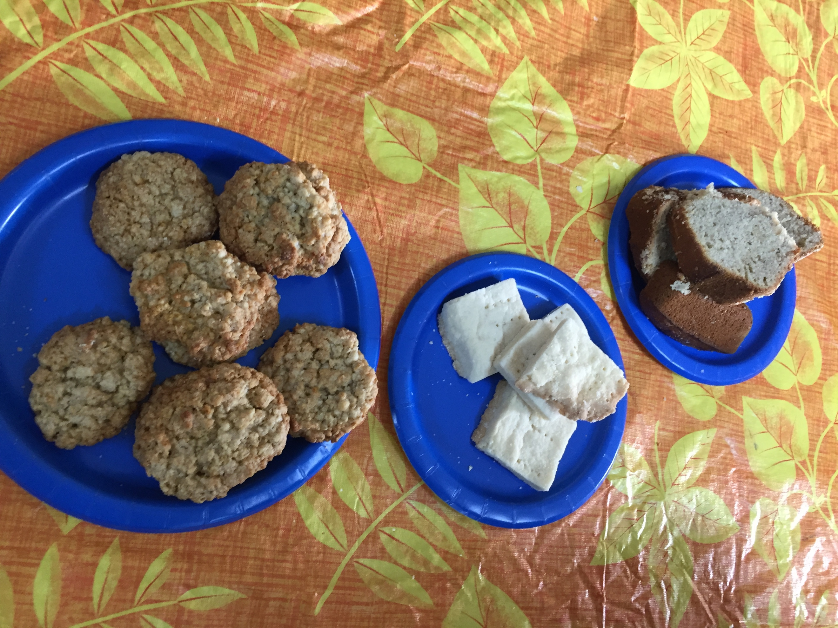
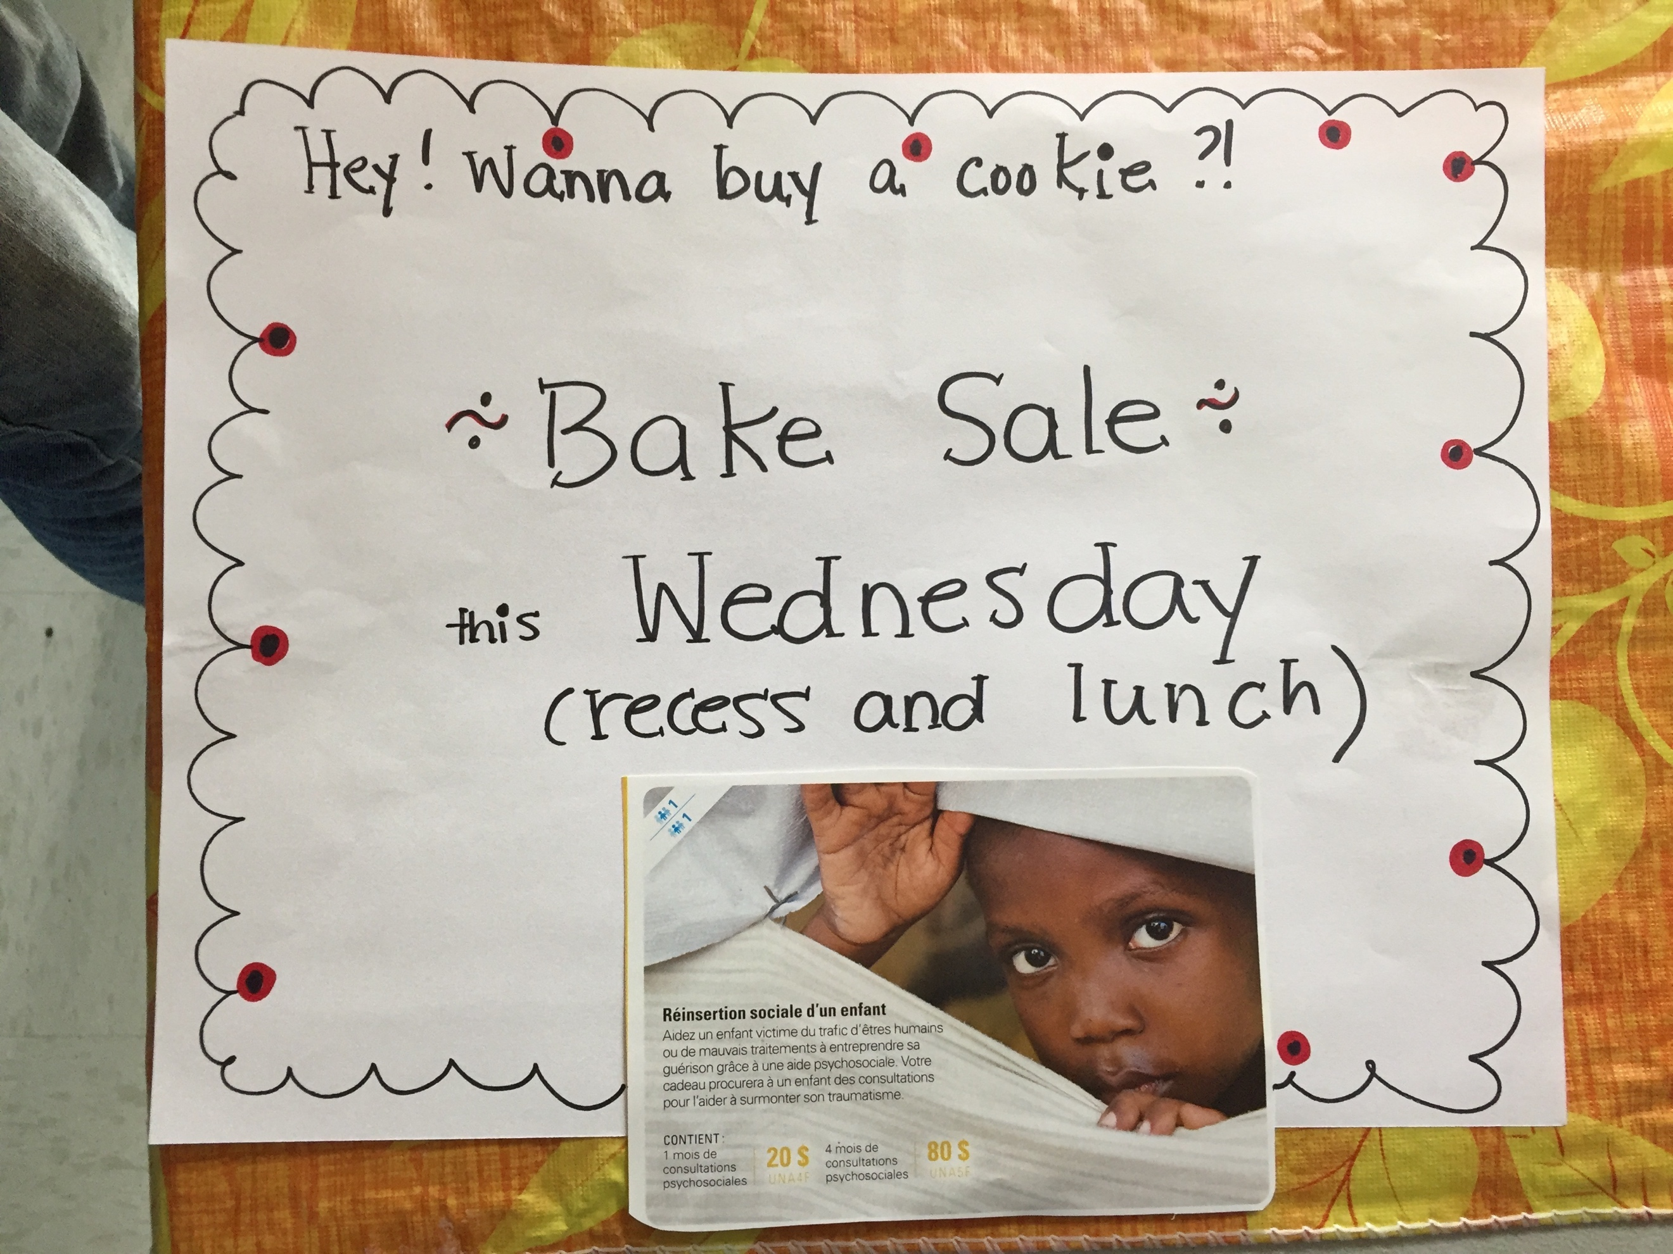

With Christmas in mind, our grade 5 class was in the mood to give. We’d come across the UNICEF Canada’s Survival Gifts® Program that offers meaningful resources to children in need, and wanted to give to this good cause.
To raise funds, parents helped us prepare a bake sale on Wednesday, December 6th at recess and at lunch time. Students sold the items sold for $.25 and $.50, and we managed to raise a total of $96.00!
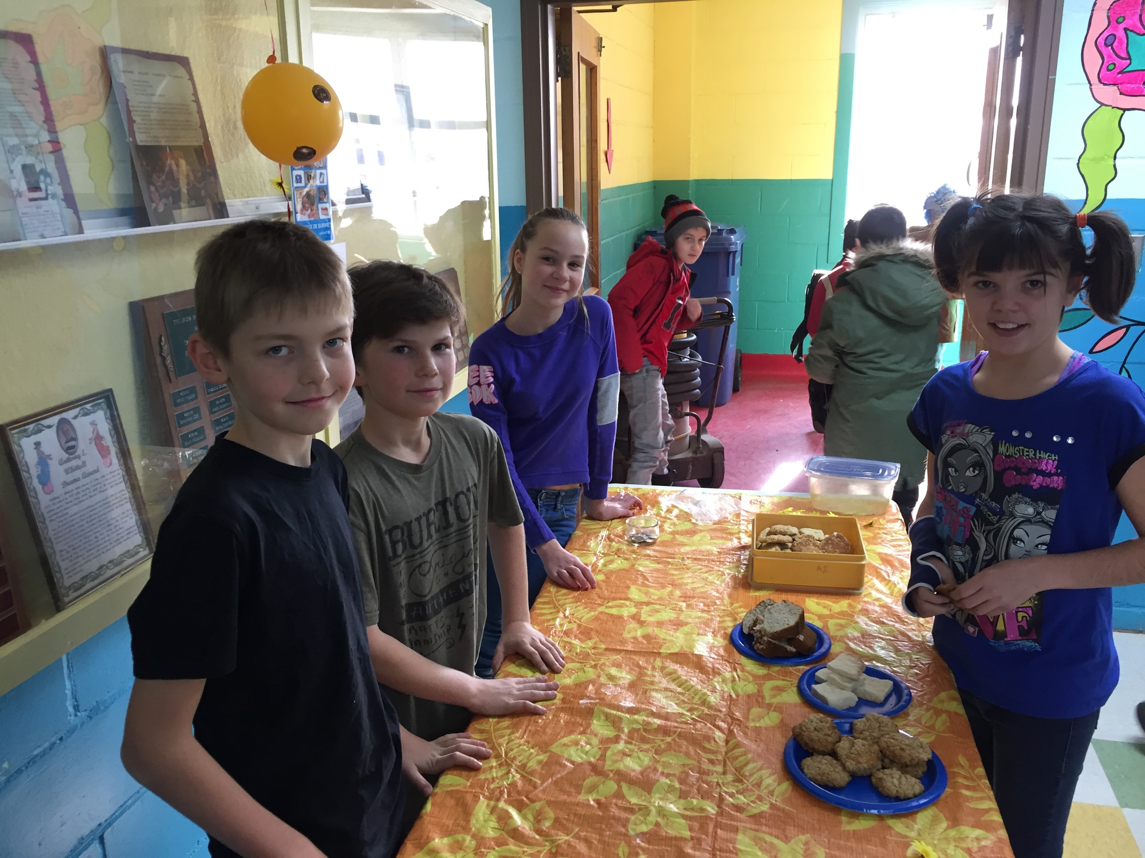
Together, we decided to purchase the vaccine pack, water purification tablets and an emergency blanket from UNICEF®, reaching 129 children. It’s amazing how far a little love and teamwork can go! I’m very proud them.

